MEMS Sensors and Actuators -- Simulation
Micro-Electro-Mechanical Systems, or MEMS, is a technology that in its most general form can be defined as miniaturized mechanical and electro-mechanical elements (i.e., devices and structures) that are made using the techniques of microfabrication. The critical physical dimensions of MEMS devices can vary from well below one micron on the lower end of the dimensional spectrum, all the way to several millimeters.
While the functional elements of MEMS are miniaturized structures, sensors, actuators, and microelectronics, the most notable (and perhaps most interesting) elements are the microsensors and microactuators. Microsensors and microactuators are appropriately categorized as “transducers”, which are defined as devices that convert energy from one form to another. In the case of microsensors, the device typically converts a measured mechanical signal into an electrical signal.
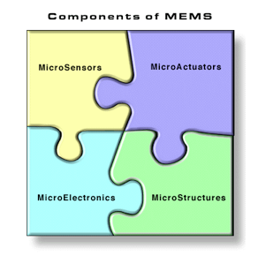
The real potential of MEMS starts to become fulfilled when these miniaturized sensors, actuators, and structures can all be merged onto a common silicon substrate along with integrated circuits (i.e., microelectronics). While the electronics are fabricated using integrated circuit (IC) process sequences (e.g., CMOS, Bipolar, or BICMOS processes), the micromechanical components are fabricated using compatible "micromachining" processes that selectively etch away parts of the silicon wafer or add new structural layers to form the mechanical and electromechanical devices. It is even more interesting if MEMS can be merged not only with microelectronics, but with other technologies such as photonics, nanotechnology, etc. This is sometimes called “heterogeneous integration.” Clearly, these technologies are filled with numerous commercial market opportunities.
In order to rapidly and efficiently utilize MEMS technology, engineers are taking advantage of MEMS design software. Simulation tools for MEMS enable engineers to model concepts and virtually build the device and predicts its behavior. Software allows engineers to simulate devices before generating a process flow or to virtually prototype and simulate devices using their process flow, before entering into fabrication.

Hands on Training for Simulation of Electro-Thermal Actuator:-

Electrothermal actuators are capable of providing larger displacements compared to electrostatic actuators. Thermal actuators are of two types. Bimorph thermal actuator and single material Electro Thermal Compliant (ETC) actuator. Electrothermal actuators have promising applications in MEMS as they have been demonstrated to be compact, stable, and high-force actuation apparatus. Here 2 different electro-thermal actuators are going to be presented. They are named V-beam actuator and U-beam actuator based on their geometry.

The Joule heating and thermal expansion physics is the working principle of the electro-thermal microactuator. According to this physics, the resistance of the material varies with respect to the temperature of the structure. The relation between the material resistance and temperature is given in Eq. (1).
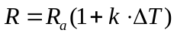 (1)
where R is resistance of material, Ra is ambient temperature resistance, k is temperature coefficient of the material and ΔT is change in temperature. When an electric pulse is applied between its voltage and ground nodes, then there will be a current flow through it and will get thermally expanded. The resultant change in temperature of the material is given in Eq. (2).

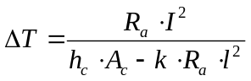 (2)
where ΔT is change in temperature, Ra is ambient temperature resistance, hc is convective heat transfer coefficient, Ac is convectional area and I is current Intensity.

∆L, due to thermal expansion can be obtained by equation (3)
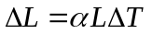 (3)
where α is the coefficient of thermal expansion of material, L is the original length of the element and ∆T is the temperature difference

V-beam Electro-Thermal Actuator:

Modeling Instructions

From the File menu choose New
In the New Window click the Model Wizard button
Model Wizard
In the Model Wizard click the 2D button
In the select physics tree, select Structural mechanics--> Joule heating and Thermal Expansion
Click the Add button
Click the Study Button and select Stationary-->Done

1. Geometry:

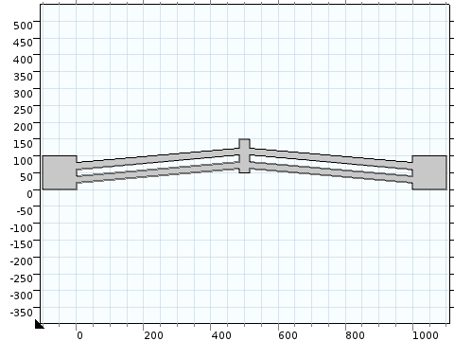

Select Length unit as µm

1.1 Drawing Procedure:
Rectangle 1 (R1)
Right click Geometry select Rectangle
In the Rectangle settings window, locate the Size section
In the Width edit field, type 100
In the Height edit field, type 100
Locate the Position section, in the X edit field, type -100 and Y edit field, type 0
Click Build all Objects
Rectangle 2 (R2)
Right click Geometry select Rectangle
In the Rectangle settings window, locate the Size section
In the Width edit field, type 495
In the Height edit field, type 20
In the Angle edit field, type 5
Locate the Position section, in the X edit field, type -1 and Y edit field, type 20
Click Build all Objects

Copy 1 (C1)
Right click Geometry, select Copy from Transforms option
Select R2
Locate the Position section, in the X edit field, type 0 and Y edit field, type 40
Click Build all Objects

Mirror 1 (M1)
Right click Geometry, select Mirror from Transforms option
Select R1,R2 and C1
Locate the Position section, in the X edit field, type 500 and Y edit field, type 0
Locate plane normal as {X,Y} = {-1,0}
Click Build all Objects

Rectangle 3 (R3)
Right click Geometry select Rectangle
In the Rectangle settings window, locate the Size section
In the Width edit field, type 30
In the Height edit field, type 100
Locate the Position section, in the X edit field, type 485 and Y edit field, type 50
Click Build all Objects

Union 1(U1)
Right click Geometry, select Union from Boolean operations option
Select R1,R2,R3,C1 and M1
Off the Keep interior boundaries
Click Build all Objects

Right click on Definitions and choose Maximum (maxop) from Component coupling. Select upper middle boundary of V-beam to measure the maximum displacement.

Material
Choose Si-Polycrystalline Silicon from MEMS-->Semiconductor in the material Library
Material Parameters
Name | Value | Unit
Electrical conductivity | 0.25e4 | [S/m]S/m
Coefficient of thermal expansion | 2.6e-6 | [1/K]1/K
Heat capacity at constant pressure | 678 | [J/(kg*K)]J/(kg*K)
Relative permittivity | 4.5 | 1
Density | 2320 | [kg/m^3]kg/m^3
Thermal conductivity | 34 | [W/(m*K)]W/(m*K)
Young's modulus | 160E9 | [Pa]Pa
Poisson's ratio | 0.22 | 1

Physics Settings
Joule heating and Thermal expansion physics

Solid Mechanics- Right click and select Fixed Constraint
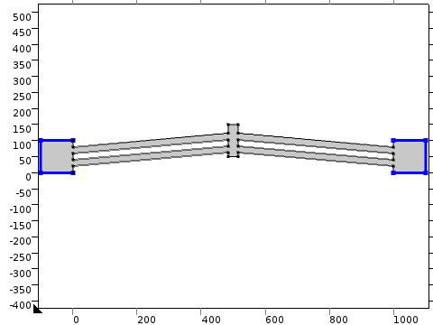

Heat Transfer in Solids-Right click and select Temperature 1
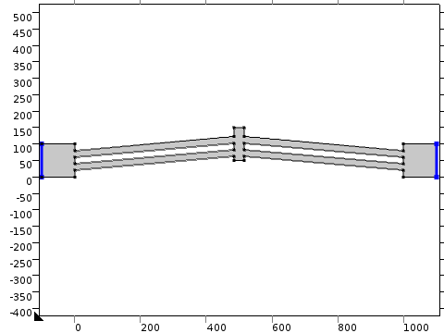
Heat Transfer in Solids-Right click and select Heat flux 1
Boundary selection-All boundaries and unselect boundaries where Temperature is defined
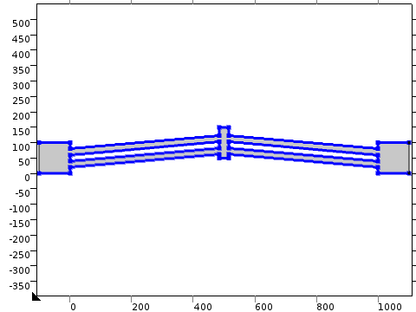
SETTINGS
Description | Value
Heat flux | Inward heat flux
Heat transfer coefficient | 5
External temperature | 293.15[K]
Frame type | Spatial
Electric Currents-Right click and select Ground
Ground 1 V=0
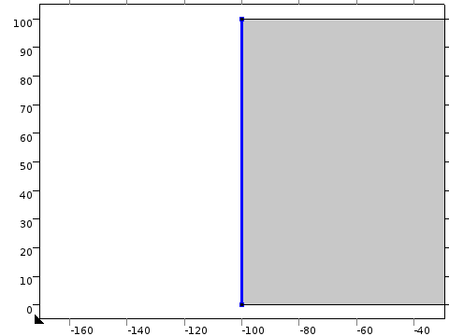

Electric Currents-Right click and select Electric Potential
Electric Potential 1
V=5V (Variable)
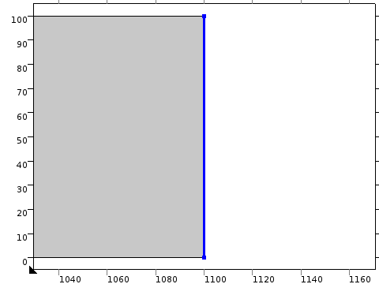

Mesh 1
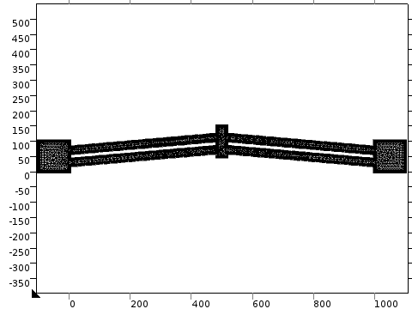
Select Sequence type as Physics controlled Mesh and choose element size as extremely fine

Study 1
Right click on Study 1 and select Show Default solver
Right click Study 1 and select Compute
1. Stress(Tem)
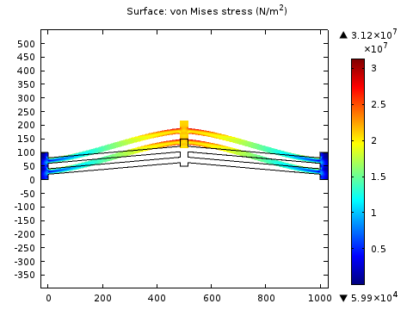

2. Current Density (Tem)
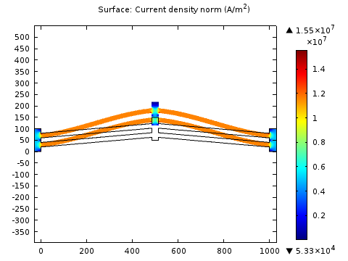
3. Temperature (Tem)
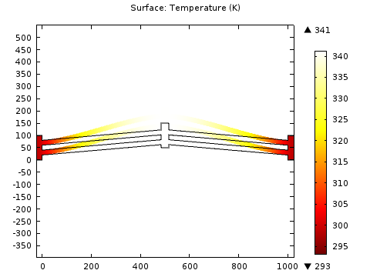
4. Displacement plot
Right Click on Results and select 1D plot Group1
Right click on 1D plot group 1 and select Global
Give expression as maxop1(v) to view the displacement plot

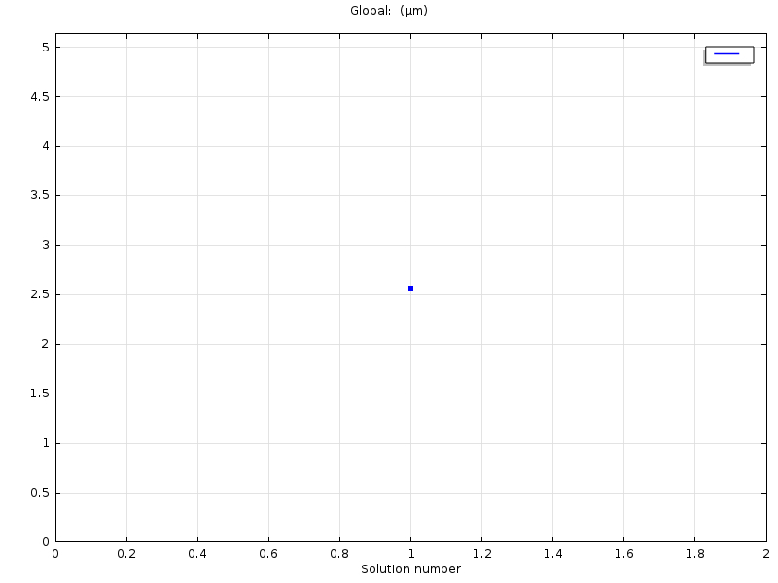

U-beam Electro-Thermal Actuator:

From the File menu choose New
In the New Window click the Model Wizard button
Model Wizard
In the Model Wizard click the 2D button
In the select physics tree, select Structural mechanics--> Joule heating and Thermal Expansion
Click the Add button
Click the Study Button and select Stationary-->Done

Geometry :

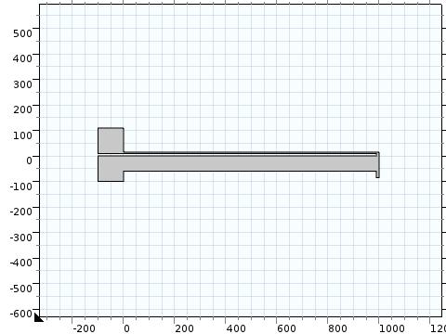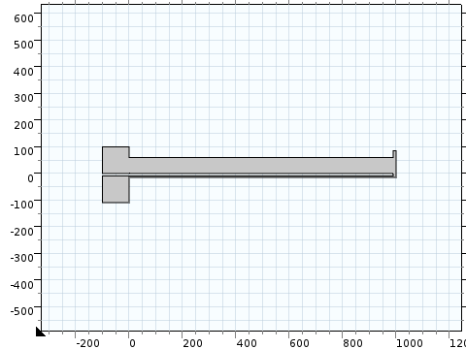
Downward Movement Upward Movement
Select Length unit as µm

1.1 Drawing Procedure:

Rectangle 1 (R1)
Right click Geometry select Rectangle
In the Rectangle settings window, locate the Size section
In the Width edit field, type 100
In the Height edit field, type 100
Locate the Position section, in the X edit field, type -100 and Y edit field, type 0
Click Build all Objects

Copy 1 (C1)
Right click Geometry, select Copy from Transforms option
Select R1
Locate the Position section, in the X edit field, type 0 and Y edit field, type -110
Click Build all Objects

Rectangle 2 (R2)
Right click Geometry select Rectangle
In the Rectangle settings window, locate the Size section
In the Width edit field, type 1000
In the Height edit field, type 60
Locate the Position section, in the X edit field, type -1.5 and Y edit field, type 0
Click Build all Objects
Rectangle 3 (R3)
Right click Geometry select Rectangle
In the Rectangle settings window, locate the Size section
In the Width edit field, type 1000
In the Height edit field, type 6
Locate the Position section, in the X edit field, type -1.5 and Y edit field, type -16
Click Build all Objects
Rectangle 4 (R4)
Right click Geometry select Rectangle
In the Rectangle settings window, locate the Size section
In the Width edit field, type 10
In the Height edit field, type 100
Locate the Position section, in the X edit field, type 990 and Y edit field, type -16
Click Build all Objects
Union 1(U1)
Right click Geometry, select Union from Boolean operations option
Select R1,R2,R3,R4 and C1
Off the Keep interior boundaries
Click Build all Objects

Right click on Definitions and choose Maximum (maxop) from Component coupling.
Select upper middle boundary of V-beam to measure the maximum displacement.

Choose Si-Polycrystalline Silicon from MEMS-->Semiconductor in the material Library
Material Parameters

Name | Value | Unit
Electrical conductivity | 0.25e4 | [S/m]S/m
Coefficient of thermal expansion | 2.6e-6 | [1/K]1/K
Heat capacity at constant pressure | 678 | [J/(kg*K)]J/(kg*K)
Relative permittivity | 4.5 | 1
Density | 2320 | [kg/m^3]kg/m^3
Thermal conductivity | 34 | [W/(m*K)]W/(m*K)
Young's modulus | 160E9 | [Pa]Pa
Poisson's ratio | 0.22 | 1

Physics Settings
Joule heating and Thermal expansion physics

Fixed Constraints 1:
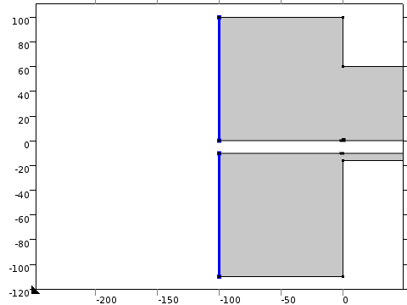
Temperature 1:
Heat Flux 1:
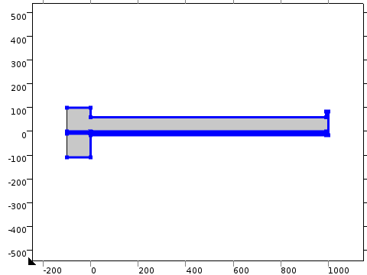
SETTINGS
Description | Value
Heat flux | Inward heat flux
Heat transfer coefficient | 5
External temperature | 293.15[K]
Frame type | Spatial
Ground 1: V=0V
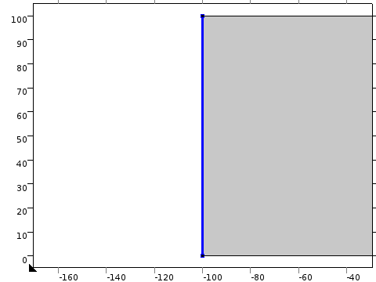
Select the anchor with thicker beam as ground node.
Electric Potential 1: V=5V
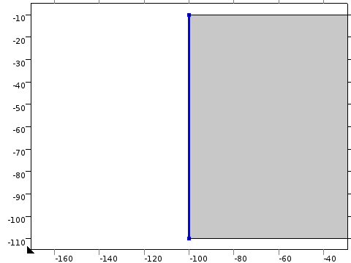
Select the anchor with thinner beam as voltage node.
Mesh 1:
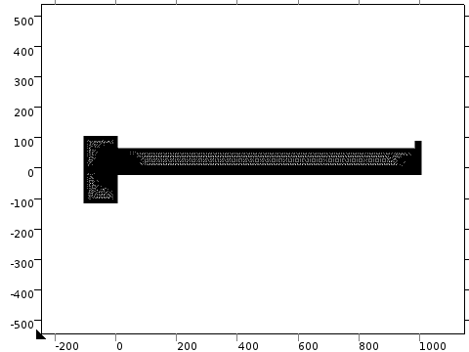
Select Sequence type as Physics controlled Mesh and choose element size as extremely fine.
Study 1
Right click on Study 1 and select Show Default solver
Right click Study 1 and select Compute

Study Results:
Stress (Solid)
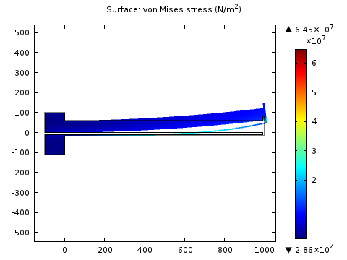
Temperature (Ht)
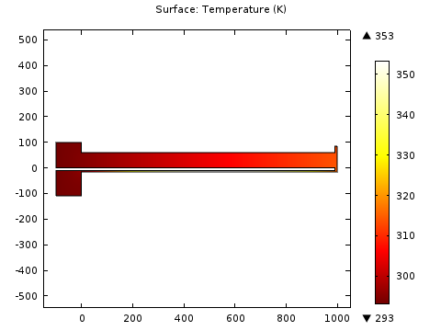
Electric Potential(Ec)
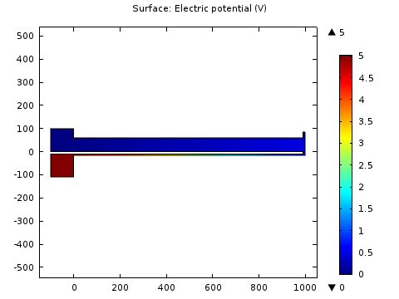
Displacement plot
Right Click on Results and select 1D plot Group1
Right click on 1D plot group 1 and select Global
Give expression as maxop1(v) to view the displacement plot

